Revolution Week 1/2- Writing Tasks

Task 1- To create a character profile.
- Imagine you are one of the domestic staff of a large Victorian household. -Decide who they might be, such as a cook, butler, maid, housekeeper, kitchen maid or footman.

-Assume a name and background story, building up a suitable character profile.

-Think about your character’s history, including where they live, what jobs they have had before, their family and how old they are. -Think about the daily tasks they would do, using books and online resources to research and collect information.

- Decide how you would like to present their character profile.

-One way to present your profile might be to search online for an image to match their Victorian character, then print and record their ideas about the image. -Or you could create a diary entry, in which you share all the information about your character from a first- person perspective.

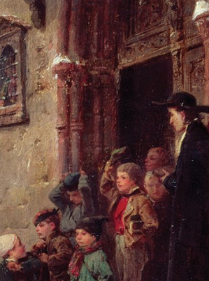
-You could write a script or conversation between two different characters, using dialogue to share information about the character profiles.
Learning Intentions:
Describe settings, characters and atmosphere using well-chosen vocabulary, integrating dialogue effectively.
In narratives, describe settings, characters and atmosphere and integrate dialogue to convey character and advance the action.

Task 2- To plan a short story.
- Visit https://www.bbc.co.uk/teach/school-radio/history-victorians-working-in-service/zvt6qp3 to listen to the BBC short story about a maid working in a large Victorian Household. (You can also download the script).
- Using this as a basis, you are going to plan a short story about a working-class character in the Victorian Era. You may choose to write a story about a maid, but equally you could choose a chimney sweep, matchmaker, farm worker etc.
- Draw a story map to help you plan out your story, using symbols and small illustrations.

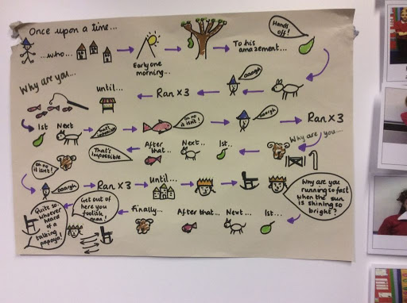
- Flashback is used in The Maid to enhance the story. Could you include a flashback sequence in your story? If you are using a flashback, remember that the tense will change- this is a good opportunity to practice your progressive and perfect tenses! -There are different ways to trigger flashback in a story. One of the easiest is a character experiencing sights, sounds, smells, tastes, textures, music, places, people, or a specific event that triggers a memory. -Dreams are another good way of prompting a flashback sequence.
Learning Intentions
-Make detailed notes on an appropriate planning format, drawing on reading and research where necessary.
-To plan writing.

Task 3- To write a short story.
- Now that you have planned your story, you can write it out! Once you have written your story, here are some things I would like you to check. Imagine that it is your success criteria…if you have a highlighter or coloured pen, you could even underline the evidence in your work!

- I can proof read my work for spelling and punctuation errors, and make the necessary corrections.
- I have used the correct tense throughout my work (bonus challenge- I have used the progressive and/or perfect tenses)
- I have used a variety of different sentence types. For example:
- Fronted adverbial sentences e.g As the sun was setting, Mitch was finally preparing to leave the factory.
- Relative clause sentences e.g The workhouse, which was a desolate and foreboding building, was home to many unfortunate souls.
- Multiclausal sentences e.g Annie had worked her fingers to the bone; The mistress would not tolerate idleness.
- Short sentences for effect e.g And then came the crack of the whip.

- I have used the correct punctuation to show speech.
- I have used paragraphs to organise my writing.

