**Classroom secrets parent guidance - Maths**

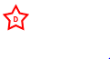

You will notice that under each challenge there is a star. This star relates to the difficulty of the question. All children should be able to complete all the although some may still need support. Other children who find it easier, must make their way through the questions and continue until they reach . If the children find these questions hard they can then stop there. They do not need to continue.

It is really important for children to be able to explain why they have done certain things, so if you can make sure that after each maths challenge ( each lesson, not each question ) they can reason a chosen question. This is something the children do every day in class, so it should be relatively easy for them.

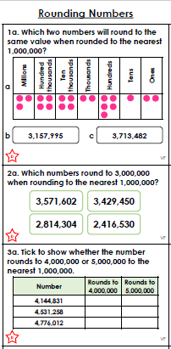

**Make all the numbers into the same representation to then round them to the nearest M.**

**How to Round Numbers**

* Decide which is the last digit to **keep (**When you are rounding to the nearest million it is the digit in the millions column.)
* Leave it the same if the **next digit** is less than 5 (this is called *rounding down*)
* But increase it by 1 if the next digit is 5 or more (this is called *rounding up*)

If you are struggling, drawing a number line might help. Make sure you find the millions benchmarks on either side of the number and place your number between them correctly. Which one is closer?

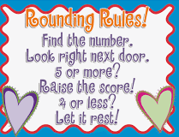

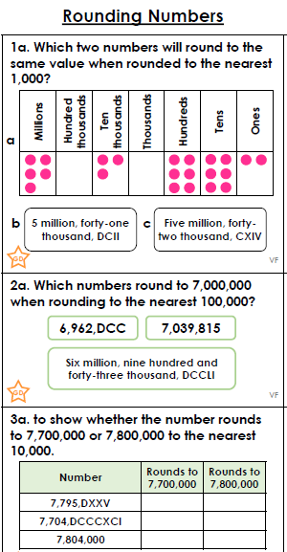

Here you need to convert Roman numerals into Arabic numerals in order to round and compare them. In case you forgot the value of some roman numerals, here is a chart:

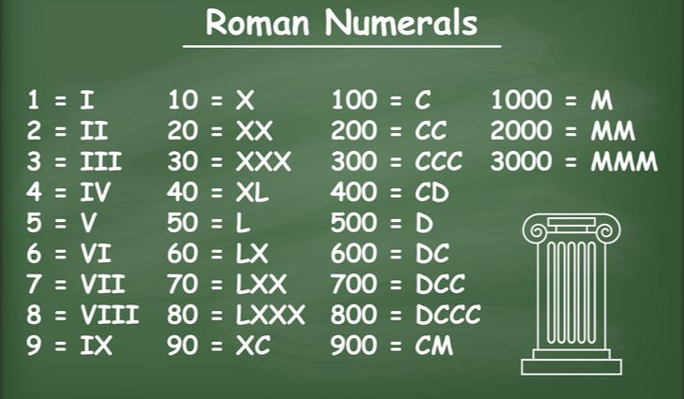

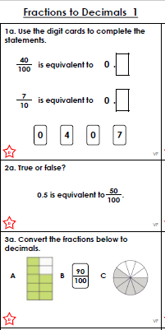

* **Step 1**: Find a number you can multiply by **the bottom of the fraction** to make it 10, or 100, or 1000, or any 1 followed by 0s.
* **Step 2**: Multiply both top and bottom by that number.
* **Step 3**. Then write down just the top number, putting the decimal point in the correct spot (one space from the right hand side for every zero in the bottom number)

## 

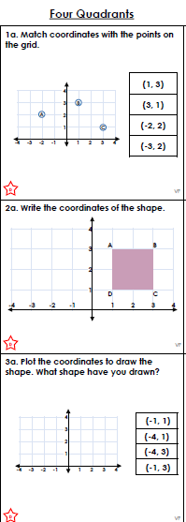

**How to read and plot coordinates**

Coordinates are always written in brackets, with the two numbers separated by a comma. **Coordinates are ordered pairs of numbers; the first number number indicates the point on the x axis and the second the point on the y axis.**

When reading or plotting coordinates you always go across first and then up (a good way to remember this is: 'across the landing and up the stairs').

Children start to learn about co-ordinates in Year 5. For example: they may be shown the above triangle and asked to write the three coordinates for the three vertices of the triangle. This would constitute **reading coordinates**. They may then be given a blank grid and asked to **plot the following coordinates**: (1, 1) (4, 1) (1, 3) and (4, 3) then join up the points to make a shape (which in this case would be a rectangle).

In Year 6, children learn to draw, locate and complete shapes that meet given properties. For example:

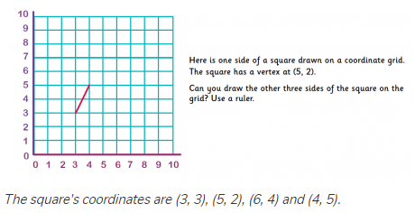

They may also be asked to [reflect](https://www.theschoolrun.com/what-is-symmetry), [rotate](https://www.theschoolrun.com/what-is-rotation-of-shapes) or [translate](https://www.theschoolrun.com/what-is-translation-of-shapes) a shape on a coordinates grid and then give the coordinates of the new shape they have drawn.

In Year 5 or 6, a child might be given a shape that has some coordinates marked on, but where the coordinates grid is not marked. They will then need to work out the coordinates of the unmarked vertex of the shape, for example:

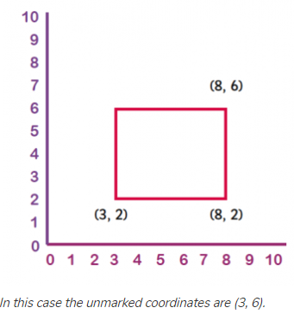

In Year 6, children are sometimes asked to work out coordinates in all four quadrants. This means they have to think about [negative and positive numbers](https://www.theschoolrun.com/what-are-negative-numbers).

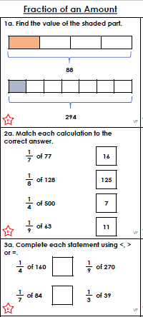

When finding a fraction of an amount, the key rule to remember is to divide the amount by the **denominator** and multiply your answer by the **numerator**.

If asked to **increase** or **decrease** an amount by a fraction make sure you add or subtract from the original amount at the end of the question!

